Setup and Installation for Python 3.X
Link to download the Latest Version of Python: https://www.python.org/downloads/windows

1.Install Latest Python from the above link
2.Select the Proper Version- Python 3.6.8 and 64bit
Python 3.6.8rc1 - 2018-12-11
Download Windows x86-64 executable installer
3.Once downloaded the double click on installer to install the Python
4.Select the Customize location to install the Python
5.Set the Environment Variables for below paths
C:\Program Files\Python36
C:\Program Files\Python36\Scripts
C:\Program Files\Python36\Lib
C:\Program Files\Python36\DLLs

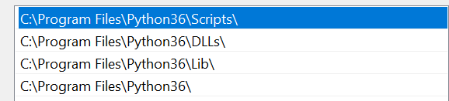

To Install Selenium
1.Run the command prompt
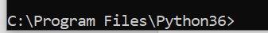
2.Run below command to install the latest Selenium
pip install selenium
3. To know the installed selenium version
python -c "import selenium; print(selenium.__version__)"

To Install IDE for Python
1.Install the PyCharm community Edition from the below link
https://www.jetbrains.com/pycharm/download/#section=windows
2.After installation set the User Environment Variable
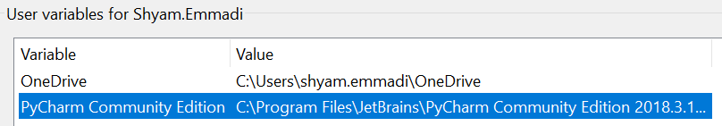

To Install Firefox and Gecko driver
1.Install the Latest Firefox – Firefox developer Version
2.Install the latest gecko driver for Firefox from the below link
https://github.com/mozilla/geckodriver/releases/tag/v0.23.0

3.Extract and copy the geckodriver.exe to any folder
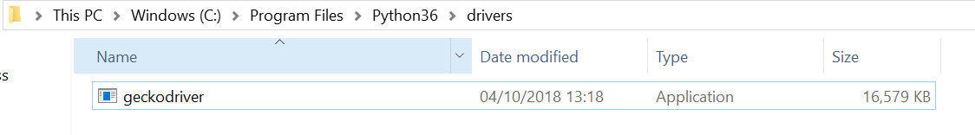
4.Set the system Environment variable for the installed gecko driver

To Install Chrome driver for Chrome browser

Setup Chropath for r Firefox and Chrome
1.Firefox – Add-ons- type ’chropath’- add
2.Restart the Firefox browser after adding the add-on ‘Chropath’

Example:
